# MODULE 06 Windows Forensics Screenshots

Lara Alofi

2110886

Y

Computer Hacking Forensic Investigator (CHFI)

Lab Session Identifiers

1. <https://labclient.labondemand.com/LabClient/05f267f3-33e5-46ee-848e-3dce0e06eaa1>

Username on EC-Council System

1. 2110886@uj.edu.sa

Lab 01

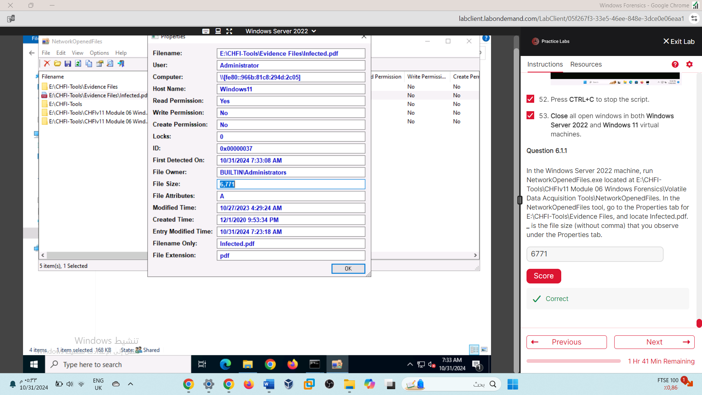

6771

Lab 02

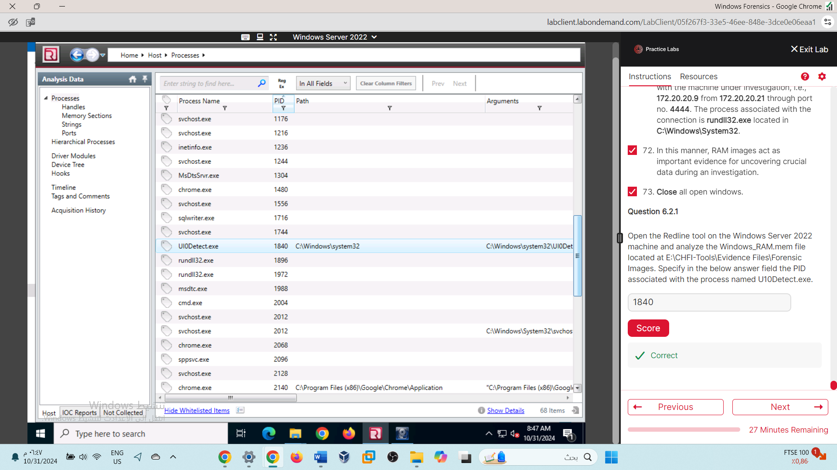

1840

Lab 03

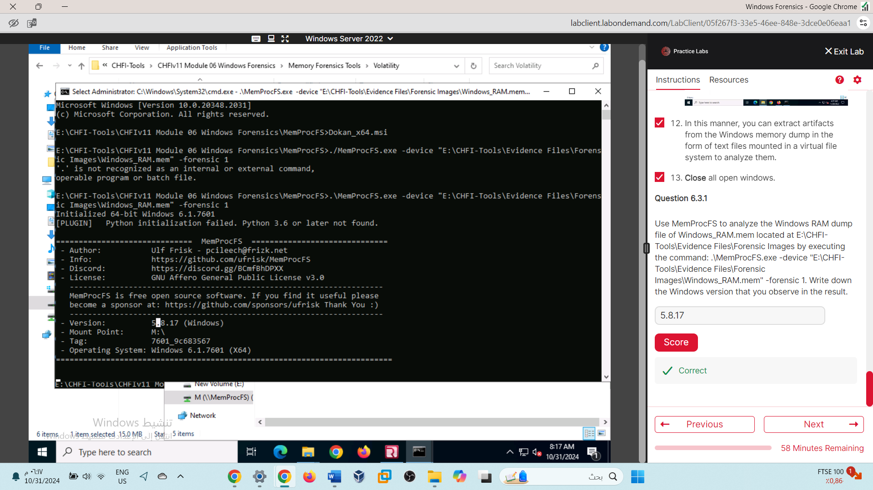

5.8.17

Lab 04

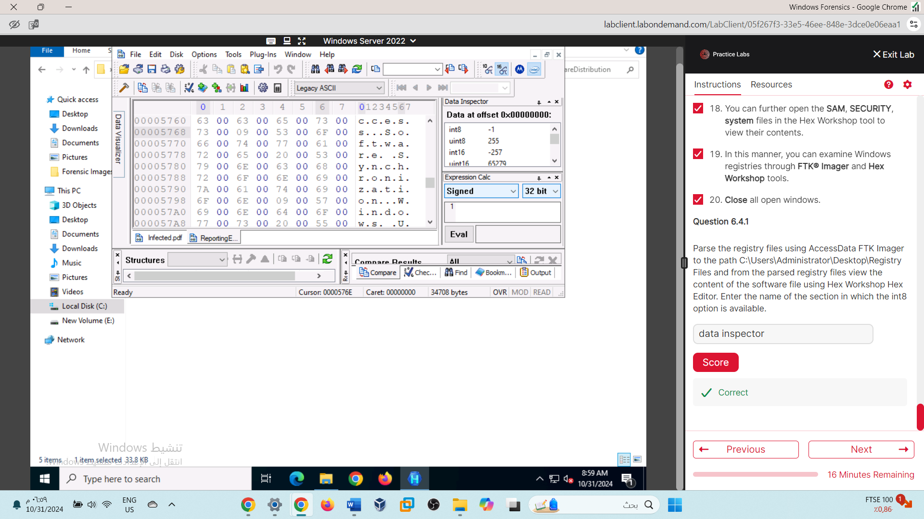

Lab 05

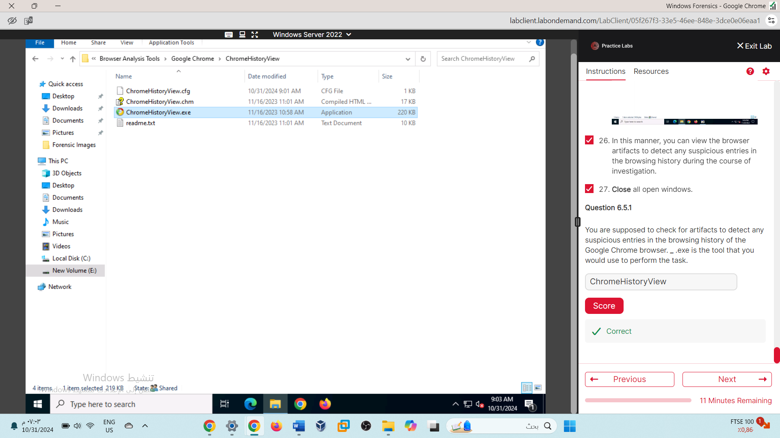

Lab 06

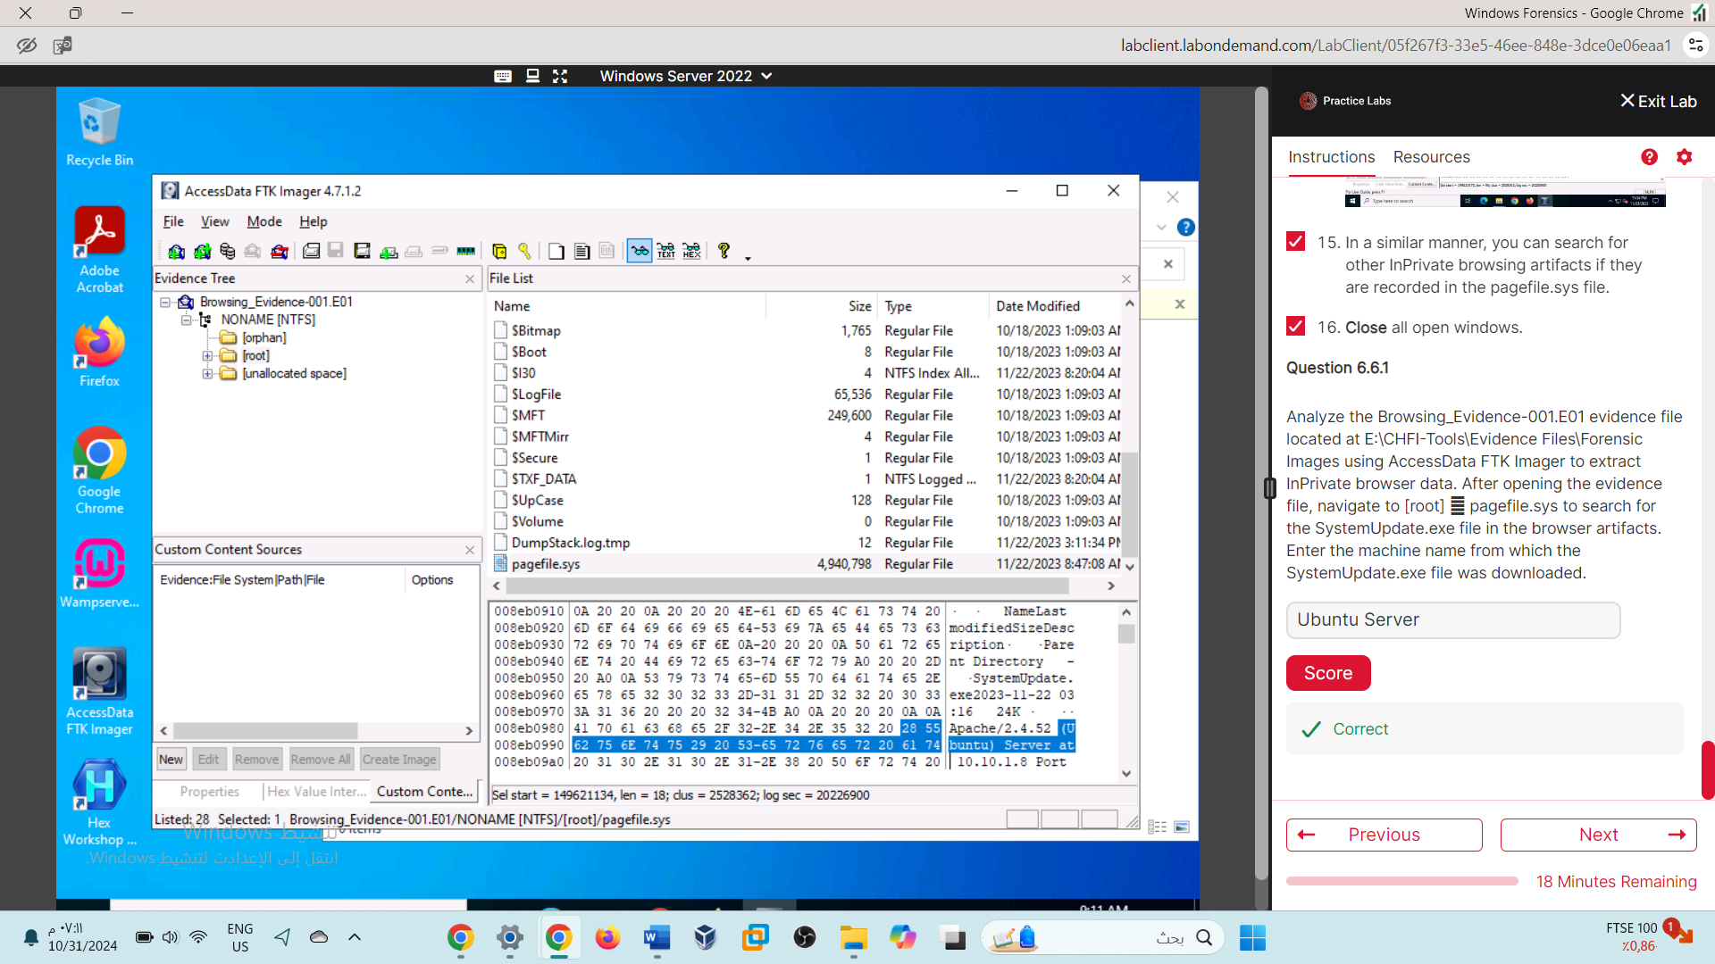

Lab 07

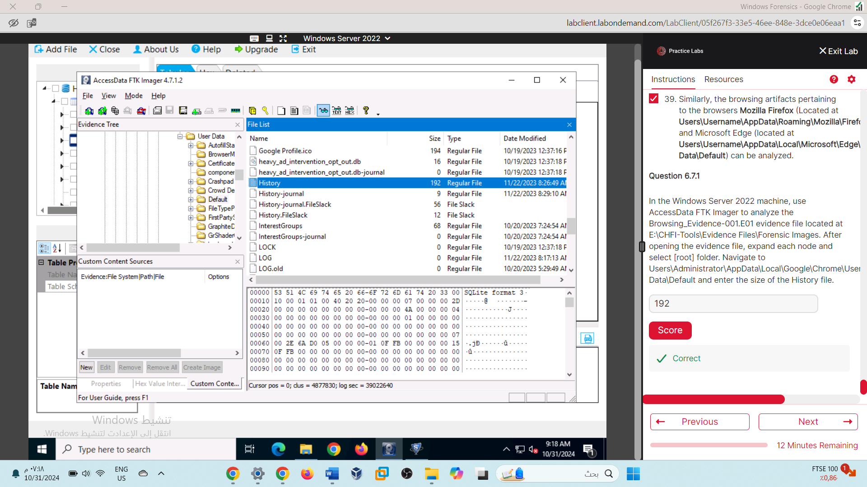

Lab 08

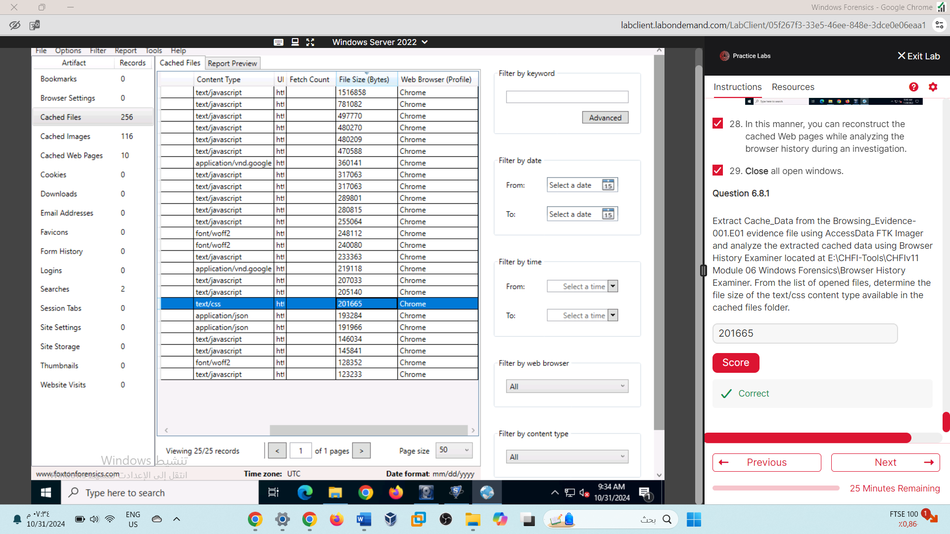

Lab 09

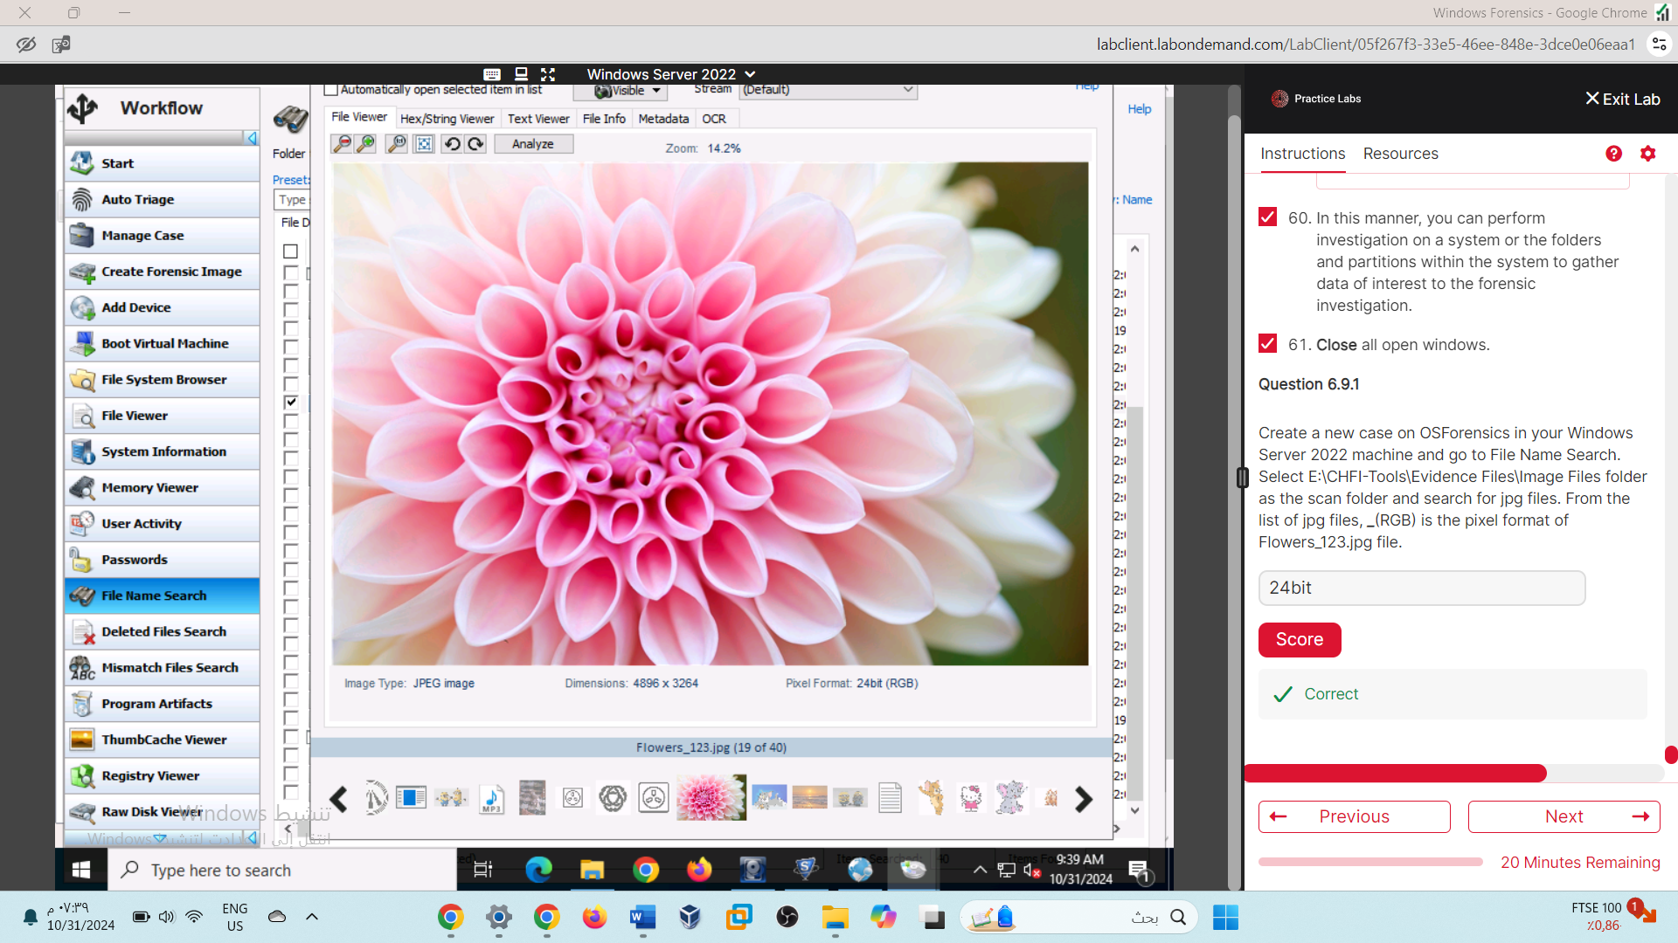

Lab10 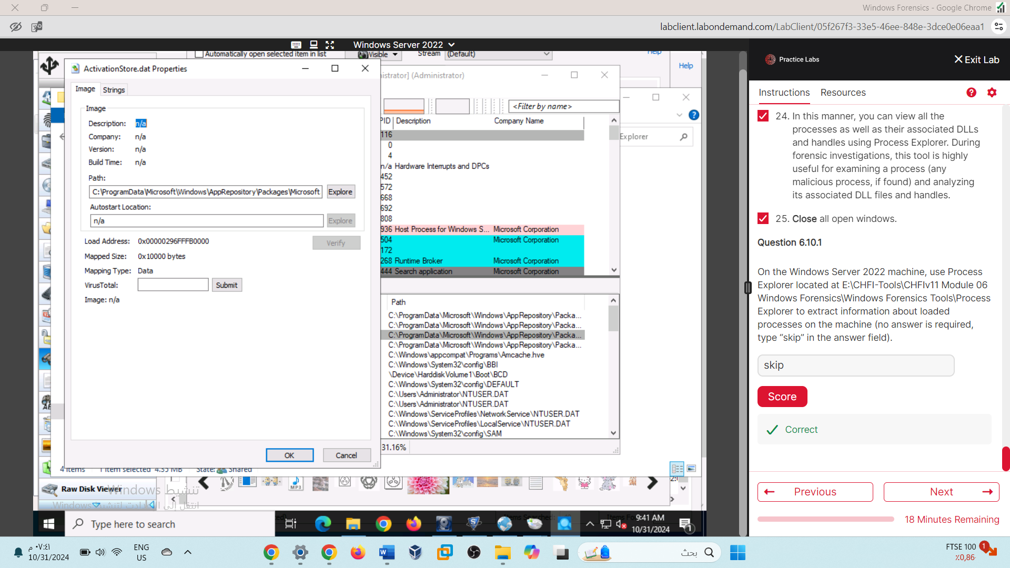

Lab11

